សាកលវិទ្យាល័យភូមិន្ទភ្នំពេញ

**Royal University of Phnom Penh**

មហាវិទ្យាល័យវិស្វកម្ម

**Faculty of Engineering**

ដេប៉ាតឺម៉ង់ វិស្វកម្មទូរគមនាគមន៍និង​អេឡិចត្រូនិច

Department of Telecommunication and Electronic Engineering

**ESP32**

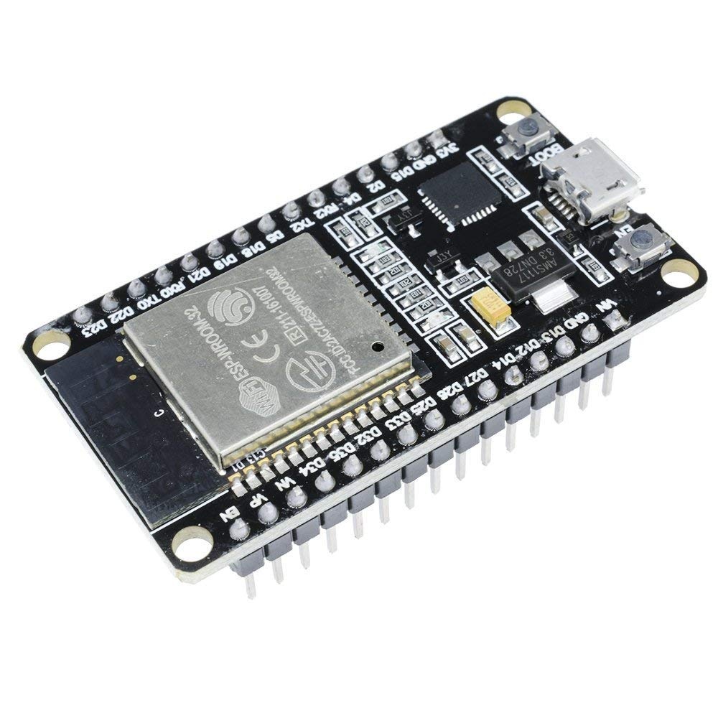

អៀន​ ស្រីនិច

Ean sreynich

**January 2023**

**Table of Contents**

1. **OVERVIEW**......................................................................................
   1. ESP32 Features and Specification...............................................................
2. **ESP32 Packaged chip and module**..................................................................
   1. ESP32 Chip...................................................................................................
   2. ESP Module ………....................................................................................

**Reference**

**List of figures**

Figure 1. ESP32 NODEMCU.............................................................................................................

Figure 2. ESP-WROOM-32...............................................................................................................

1. **OVERVIEW**

**ESP32** is a series of low-cost, low-power system on a chip microcontroller with integrated WIFI and dual-mode Bluetooth. ESP32 is created and developed by Espressif Systems, a Shanghai-based Chinese company, and is manufactured by **TSMC** using their 40 nm process. It is a successor to the **ESP8266** microcontroller.

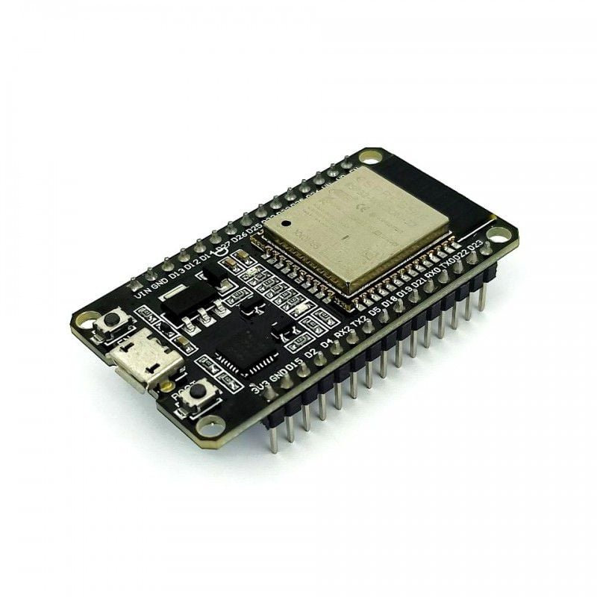

Figure 1. ESP NODEMCU

* 1. **ESP32 Features and Specification**

**Power supply of the ESP32**

* Power supply: 2.3V – 3.6V
* Current consumption: 20uA – 240mA. In deep sleep mode less than 5uA
* Operating temperature rang: -40c – 125c

**Interface**

* 34 × programmable [GPIOs](https://en.wikipedia.org/wiki/GPIO)
* 12-bit [SAR ADC](https://en.wikipedia.org/wiki/Successive_approximation_ADC) up to 18 channels
* 2 × 8-bit [DACs](https://en.wikipedia.org/wiki/Digital-to-analog_converter)
* 10 × touch sensors ([capacitive sensing](https://en.wikipedia.org/wiki/Capacitive_sensing) GPIOs)
* [SD](https://en.wikipedia.org/wiki/Secure_Digital)/[SDIO](https://en.wikipedia.org/wiki/Secure_Digital#SDIO_cards)/[CE-ATA](https://en.wikipedia.org/wiki/CE-ATA)/[MMC](https://en.wikipedia.org/wiki/MultiMediaCard)/[eMMC](https://en.wikipedia.org/wiki/MultiMediaCard#eMMC) host controller
* SDIO/SPI slave controller
* [Ethernet](https://en.wikipedia.org/wiki/Ethernet) MAC interface with dedicated DMA and planned [IEEE 1588 Precision Time Protocol](https://en.wikipedia.org/wiki/Precision_Time_Protocol) support[[4]](https://en.wikipedia.org/wiki/ESP32#cite_note-4)
* Infrared remote controller (TX/RX, up to 8 channels)
* Pulse counter (capable of full [quadrature](https://en.wikipedia.org/wiki/Incremental_encoder) decoding)
* Motor [PWM](https://en.wikipedia.org/wiki/Pulse-width_modulation)
* LED PWM (up to 16 channels)
* [Hall effect sensor](https://en.wikipedia.org/wiki/Hall_effect_sensor)
* Ultralow power analog pre-amplifier

**Network**

* WiFi 802.11 b/g/n 2.4 GHz with WPA/WPA2 PSK
* Ipv4 and ipv6 from Arduino Core 2.5.o
* Bandwidth: 150 to 300kBytes/s
* Bluetooth: Version 4.2

**CPU: 160MHz up to 240MHz**

**Internal Memory**

* 448 Kbytes ROM for booting
* 520 Kbytes on-chip SRAM for data and instruction
* 8 Kbytes SRAM in RTC

1. **ESP32 Packaged chip and module**

**2.1 ESP chips**

The ESP32 [system on a chip](https://en.wikipedia.org/wiki/System_on_a_chip) integrated circuit is packaged in both 6 mm × 6 mm and 5 mm × 5 mm sized QFN packages.

Table 1: ESP chip

|  |  |  |  |  |
| --- | --- | --- | --- | --- |
| **Identifier** | **Processor cores** | **Embedded flash memory (**[MiB](https://en.wikipedia.org/wiki/MiB)**)** | **Package size** | **Description** |
| ESP31B | 2 | 0 | 6 mm×6 mm | Pre-release [**SoC**](https://en.wikipedia.org/wiki/System_on_a_chip) used for beta testing; no longer available. |
| ESP32-D0WDQ6 | 2 | 0 | Initial production release chip of the ESP32 series. |
| ESP32-D0WD | 2 | 0 | 5 mm×5 mm | Smaller physical package variation similar to ESP32-D0WDQ6. |
| ESP32-D2WD | 2 | 2 | 2 MiB (16 Mibit) embedded flash memory variation. |
| ESP32-U4WDH | 1 | 4 | Single-core processor and 4 MiB (32 Mibit) embedded flash memory variation. |
| ESP32-S0WD | 1 | 0 | Single-core processor variation. |

**2.2 ESP32 Module**

The pins function of the ESP32 is explained in detail in the article on [the ESP32 pinout](https://www.upesy.com/blogs/tutorials/esp32-pinout-reference-gpio-pins-ultimate-guide#a289b7034a05897020d8e90be143)

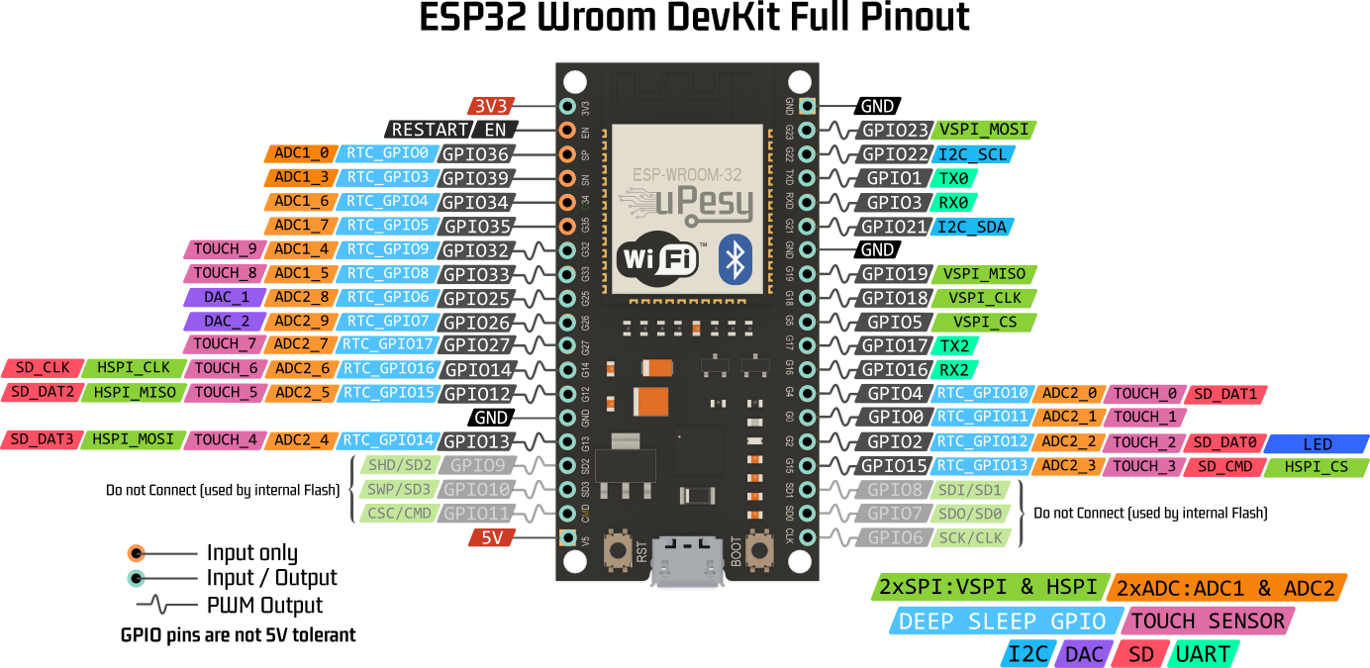

Figure 2. ESP-WROO

**Reference**

<https://www.espressif.com/en/products/modules>

<https://en.wikipedia.org/wiki/ESP32>